HOK Mass Tools

*(Updated 2013-10-16 by Jinsol Kim)*

## Overview

This tool is designed to convert geometry from Room, Area, or Floor into Mass elements. The extruded mass family will be created by boundary lines of Room/Area/Floor, and a customized height factor. In addition, all mass instances can capture shared parameters to transfer data between each mass object and the corresponding Room/Area/Floor.

## Main User Interface

## 

Contents

Overview 1

Main User Interface 1

***1.*** ***Mass form Room*** 3

1.1 Creating Room Mass 3

1.2 Importing/ Exporting Room Data 7

1.3 Recreating Room Mass 8

1.4 Additional Features (Applied to Areas and Floors) 9

1.5 Error Dialog (Applied to Areas and Floors) 10

***2.*** ***Mass form Area*** 11

2.1 Creating Area Mass 11

2.2 Importing/ Exporting Area Data 14

2.3 Recreating Area Mass 15

***3.*** ***Mass form Floor*** 16

3.1 Creating Floor Mass 16

3.2 Importing/ Exporting Floor Data 19

3.3 Recreating Floor Mass 19

***4.*** ***Mass Commands*** 20

4.1 Assigning Parameter Values 22

4.2 Splitting Elements 27

# ***Mass form Room***



Select room elements in the Revit project, and check the check box of “Selected Rooms” if you only want to see the selected rooms. Otherwise, just click the “Rooms” button, and then it will display all the existing room elements.

## Creating Room Mass

**1. Room Selection:**

Click and drag rows on the table and do mouse right-click to check selected rooms

- To individually select, tick the each check box.

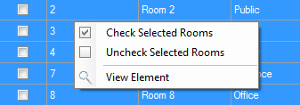

* To control all check boxes at same time, click the “Check All” button  otherwise, click the “Check None” button  to remove all checks.

1. **Shared Parameters:**

Click the “Shared Parameters” button  on the bottom left corner to add shared parameters in the mass family. All parameters will be instance parameters.

You may see the window like below.

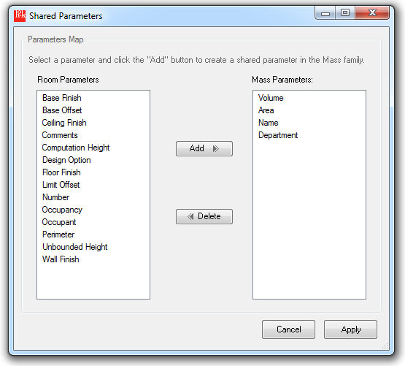

Select parameter names on the left list and click the “Add” button to make a selection. If you want to cancel the selection, select parameters from right list and click the “Delete” button.

Click the “Apply” button to define the default shared parameters that will be created on Mass family.

You can review the result of selection with red text in the main command window.

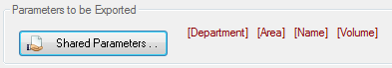

1. **Color Assignment:**

The color of mass element represents various departments of rooms.

Click a colored cell  from the column of “Color”. It will automatically change the other cells of color if the room belongs to the same department.

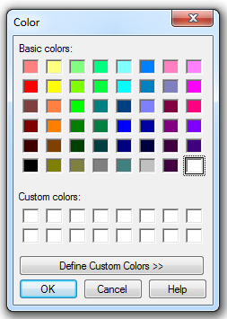

1. **Placing Masses:**

If settings are completed, click the “Place mass” button  to create mass families and load them in the current Revit project.

If all mass instances are successfully created, you may see the result dialog like below.

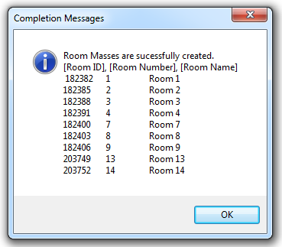

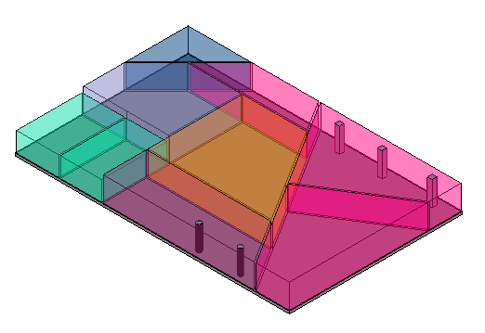

## 1.2 Importing/ Exporting Room Data

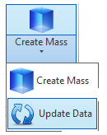

Find the split button arrow and click the “Update Data” button to open the command window.

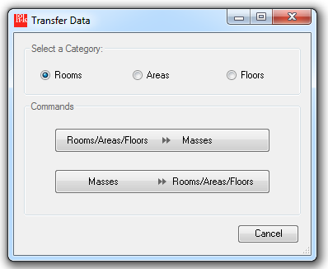

Make sure the radio button of Rooms was checked, and click a button to define the direction of the data transfer.

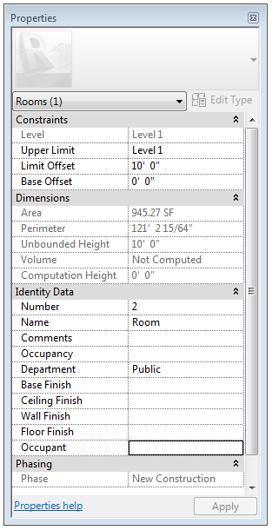 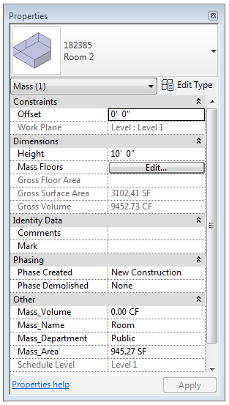

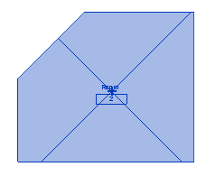 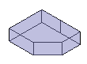

## 1.3 Recreating Room Mass

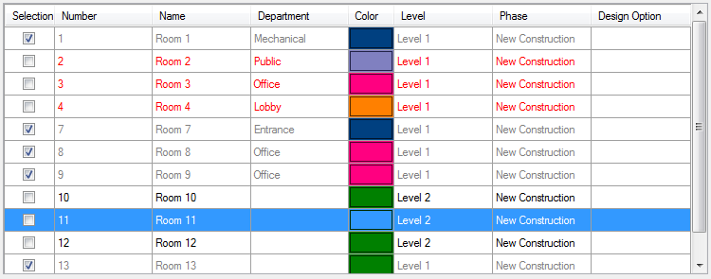

The tool will find the discrepancy of boundary lines between room elements and mass instances. When you open up the main window, you cans find them with red text with remaining the selection check box unchecked. Select rooms to replace with new mass instances.

**Tips: each room is identified by the centroid point of the room to detect the change of boundary lines.

## 1.4 Additional Features (Applied to Areas and Floors)

**1. View Element:**

To open view where a specific room is located at, mouse right-click on the row, and click “View Element” menu. It will navigate through the room with making the element selected.

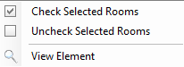 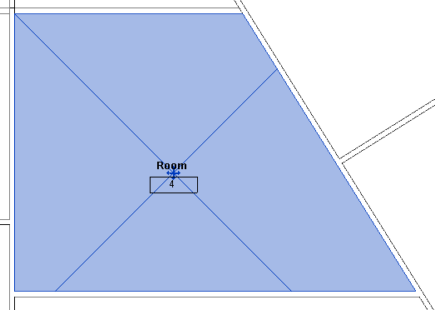

**2. Island Rooms:**

When the number of loops of boundary lines is more than two, which means it has empty space in the middle of the room elements and that needs to be excluded from the area of the room. For instance, there might be a case of a room inside another room, or some structural components like columns or walls. In this case, this tool will create a form element along the most outer line, and separate void forms following other loops of lines inside the room.

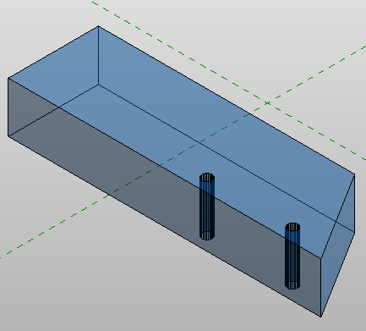

**Tips: if the inner lines are circular curves, it will make the tool work slow, because it needs to extract points on the curve and recreate approximated polylines through the points.

**3. Hosted Levels:**

The created mass instances will be placed on the work plane of certain levels where the room elements lie on.

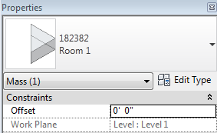

## 1.5 Error Dialog (Applied to Areas and Floors)

Untrimmed boundary lines of rooms may cause an additional time to create masses and the increase in overall inaccuracy. The warning messages will be shwon at the end of the process with room ids and names in the bracket. In case of severe problems, the tool will be stopped and request user to take an action by showing another dialog box.

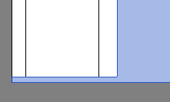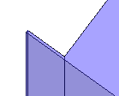 << Untrimmed boundary lines in 2D & 3D

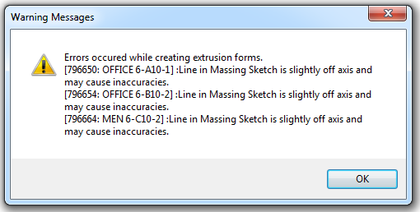

# ***Mass form Area***



Select area elements in the Revit project, and tick the check box of “Selected Areas” if you only want to see the selected areas. Otherwise, just click the “Rooms” button, and then it will display the information of all the existing area elements.

## 2.1 Creating Area Mass

**1. Area Selection:**

Click and drag rows on the table and do mouse right-click to check selected areas

- To individually select, tick the each check box.

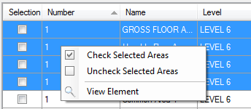

* To control all check boxes at once, click the “Check All” button  otherwise, click the “Check None” button  to remove all checks.

1. **Shared Parameters:**

Click the “Shared Parameters” button  on the bottom left corner to add shared parameters in the mass family. All parameters will be instance parameters.

Follow the same steps like the case of creating mass room.

1. **Color Assignment:**

The color of mass element represents different area types.

Click a colored cell  from the column of “Color”. It will automatically change the other cells of color if the area belongs to the same area type.



1. **Height of Mass:**

If you assign a different Height then default height, just type a number in feet, otherwise enter a default height and check the check box of Default Height. These values will define the height of extrusion of each mass instance.

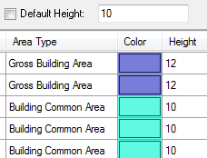

1. **Placing Masses:**

If settings are completed, click the “Place mass” button  to create mass families and load them in the current Revit project.

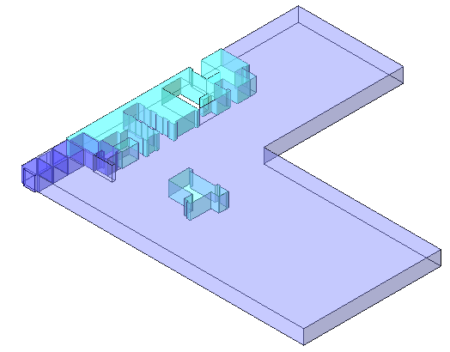

## 2.2 Importing/ Exporting Area Data

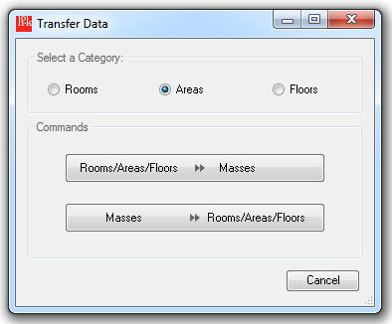

Make sure the radio button of Areas was checked, and click a button to define the direction of the data transfer.

## Recreating Area Mass

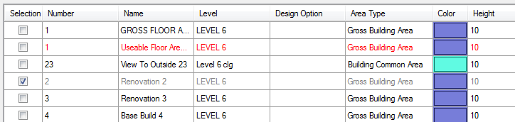

**Tips: each area is identified by the value of the area parameter of the Area element. If the value is changed, the entire row of the area element will be marked with the red text.

# ***Mass form Floor***



Select floor elements in the Revit project, and tick the check box of “Selected Floors” if you only want to see the selected floors. Otherwise, just click the “Floors” button, and then it will display the information of all the existing floor elements.

## Creating Floor Mass

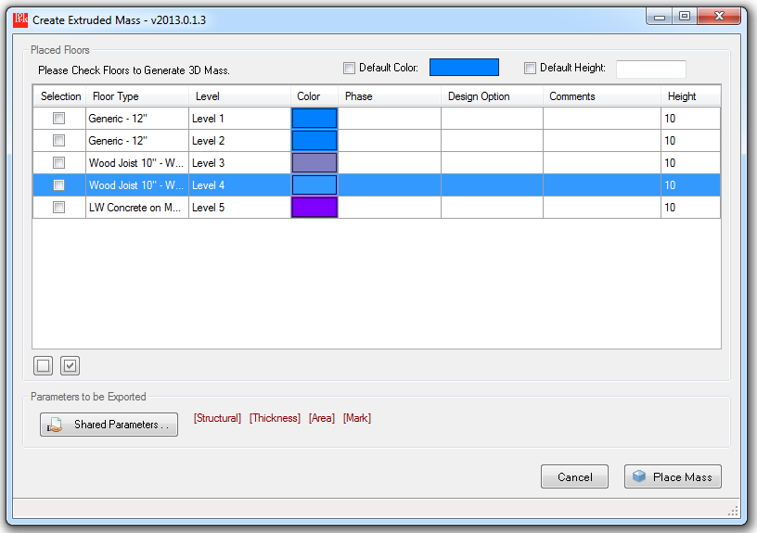

**1. Area Selection:**

Click and drag rows on the table and do mouse right-click to check selected areas

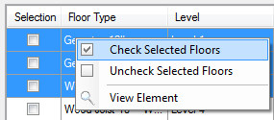

1. **Shared Parameters:**

Click the “Shared Parameters” button  on the bottom left corner to add shared parameters in the mass family. All parameters will be instance parameters.

Follow the same steps like the case of creating mass room.

1. **Color Assignment:**

You can specify the color of mass instances floors by floors.

Click a colored cell  from the column of “Color”, or click the colored button on the top right corner. If you check the check box of Default Color, it will change the color of all floor masses to the designated color.



1. **Height of Mass:**

If you want to assign a different height, just type a number in feet in the column of Height, otherwise enter a default height and check the check box of Default Height. These values will define the height of extrusion of each mass instance.

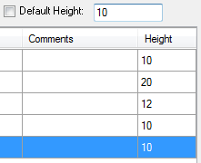

1. **Placing Masses:**

If settings are completed, click the “Place mass” button  to create mass families and load them in the current Revit project.

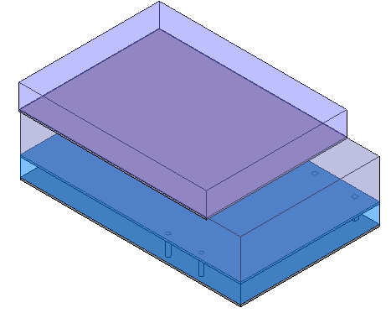

## Importing/ Exporting Floor Data

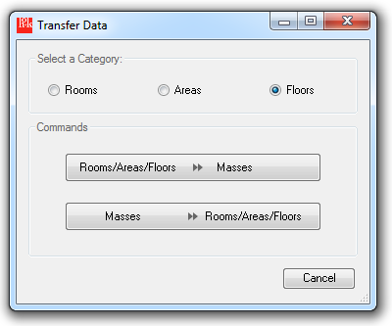

Make sure the radio button of Floors was checked, and click a button to define the direction of the data transfer.

## Recreating Floor Mass

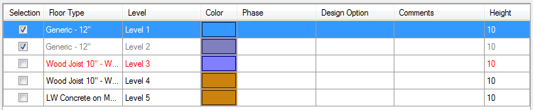

**Tips: each floor is identified by the centroid of the floor. If the outer boundary lines are changed, the entire row of the floor will be marked with the red text.

# ***Mass Commands***

This Mass Commands has two distinctive functionality using mass objects placed in Revit project. Placed mass elements can play two major roles in either “container” or “cutter”. The container means the mass can enclose other 3d model elements by certain characteristics, so that all elements lay inside the mass can inherit same parameter values as the mass has. On the other hand, a mass as a cutter can split elements by a certain face of the mass that some of elements would pass through.

In order to initialize the process, users should determine the source that mass elements come from.

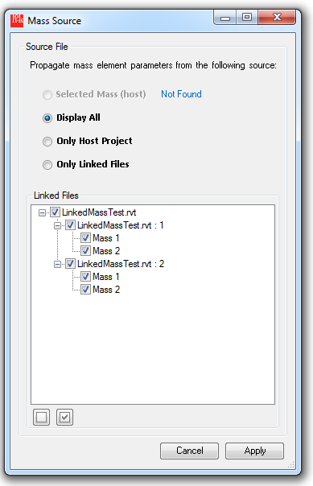

If we select one of mass source, it will start finding which elements are enclosed by a certain mass element and check if some of elements are overlay on multiple mass objects.

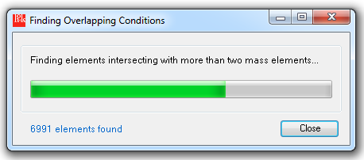

After the tool automatically creates maps between masses and elements, it will display the lists of the mass and the number of elements enclosed. 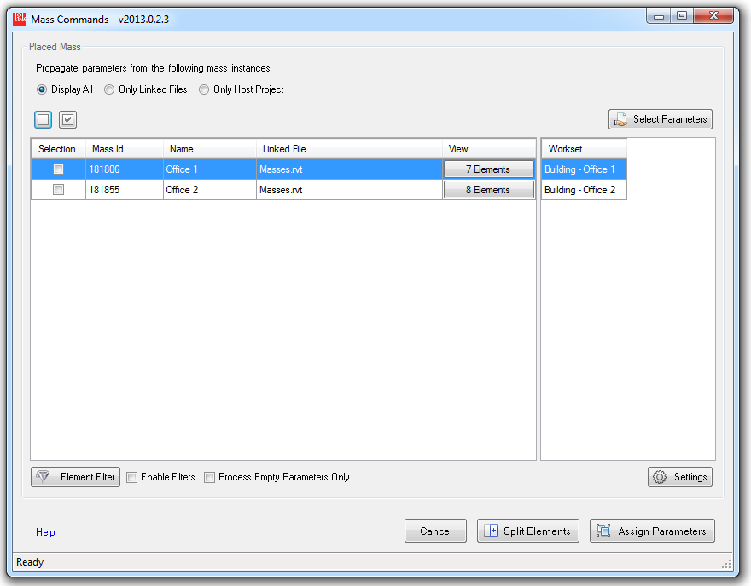

## Assigning Parameter Values

1. **Select Parameters**



In order to assign same parameter values from masses to elements enclosed, users should select parameters that will be propagated. The list will display all parameter names masses contain, so that users can make a selection group of parameters and enter parameter names of the model element to be inherited.

*Note: if names of Mass parameter start with a prefix, “Mass_”, the default element parameters will be mapped with the last part subtracting the prefix. e.g. Mass_RoomName >>RoomName

\*\***Workset** Parameter: the built-in Workset parameter from mass cannot be directly transferred to elements. In mass, users should create a string type of parameter that contains names of worksets and map to an actual Workset parameter of elements.

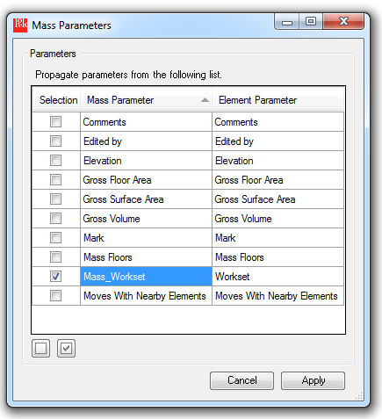

After selecting parameters, in the main command windows, selected parameter names and their values will be updated like below.

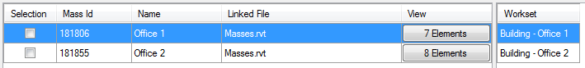

1. **Element Filter**

If only some categories of elements are required to be active on selection, we can make the group of elements filtered out using the “Element Filter”.



Tick check boxes of category names to be included in the filter.

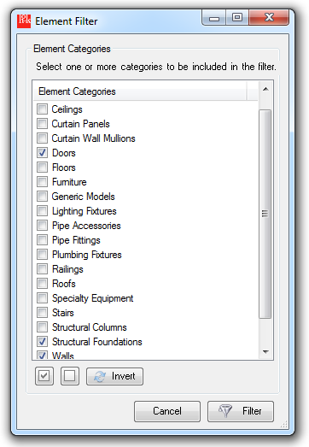

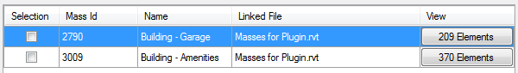

In each row, the number of elements that belongs to the selected categories in the filter will be updated.

Note that you should check the “Enable Filters” to apply the filter you defined.

1. **Parameter Filter**



You can see the parameter option right next to the options for element filter, described as Process Empty Parameters Only. If this option is selected, the tool will skip all parameters that have non-zero or non-empty string values, for instance, only newly added elements can be written with the parameter values with the option selected.

1. **View Elements**

If you are interested in viewing elements enclosed by a certain mass object, you can click buttons under the View column. Revit automatically select the elements and zoom to fit.

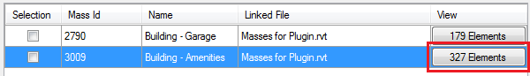

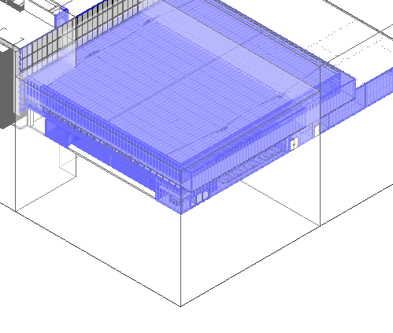

1. **Settings**



Overlapping conditions,” Mass Overlap Raito” and “Family Instance by Host Element”, can be set in the Settings window before the Overlapping Masses window appears. If there’s any preset values, it will automatically overwrite the values into the Overlapping Masses window.

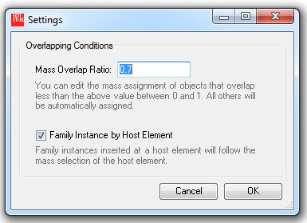

1. **Overlapping Condition**

When model elements are overlay more than two mass objects, users should determine which mass object will become a mass container for the element to transfer parameter values. The overlapping condition will be shown the ratio of intersecting volume with each mass object, and the combo box of mass selection at the last column.

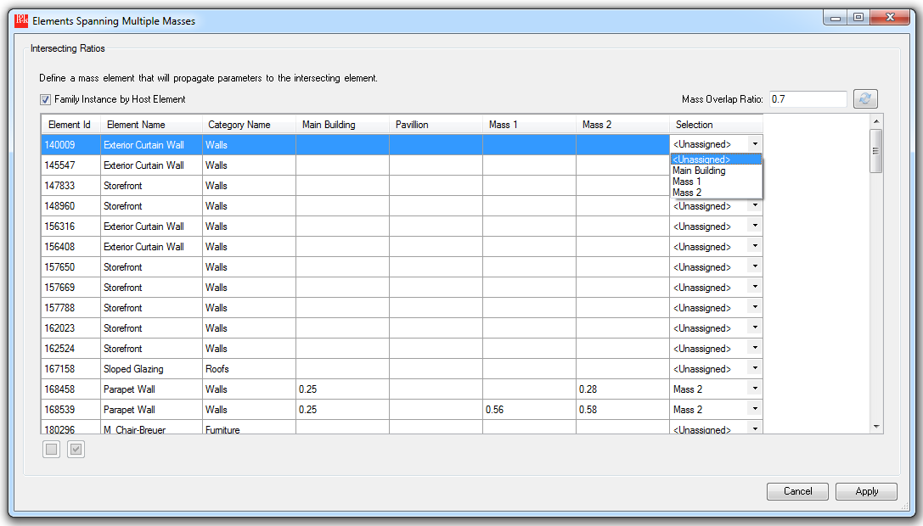

To manipulate auto-set the selection of the mass by the amount of overlapping volume, users can set the minimum overlap ratio between 0 and 1. If the difference of the volume ratio is distinctive, and the overlap ratio is larger than the value you set, it will automatically select the mass and parameter values from the selected mass will be written in the element.

**Family Instance by Host Element:

If some of family instances are hosted by elements like floors or walls, the mass selection will be automatically determined by the selection of host element.

For example, if a wall containing windows and doors is set to a mass of Building-Garage, the windows and doors will also be set to Building-Garage no matter of what the previous selection was.

**Mass Selection of <Unassigned>:

If intersecting volumes cannot be calculated, the combo box for the mass selection will be automatically display the first item, <Unassigned>, which will skip the elements for the assignment of parameter values.

## Splitting Elements



**Available categories for split:**

Architectural – Columns, Floors, Roofs, Walls

Structural – Structural Framing, Structural Columns

Mechanical – Ducts, Pipes, Conduits

The splitting Elements command will create new elements that geometrically separated with transferring all same parameter values of the original element. If the process is successful, the native element will be automatically deleted at the end.

Click the Split Elements button to proceed to make a selection of mass among overlapping masses.

Check or uncheck the list of categories to define group of elements that will be split.

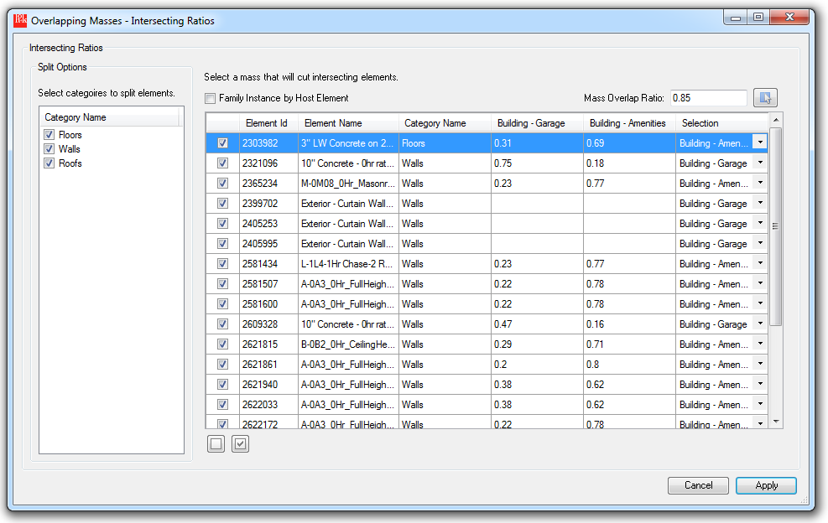

*primary elements: split by the selected mass

*secondary elements: split by the portion of the difference

1. **Floors**

>> Find the intersecting geometry of solid between the floor and the selected mass

>> Gather the information about curves from the top face of the solid.

>> Using the profile curves collected above, create a new floor

>> Repeat the same process for the secondary elements with the result of difference Boolean operation

>> Transfer parameter values from the native floor to primary and secondary elements created

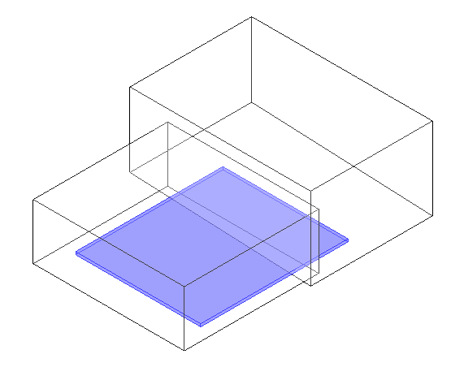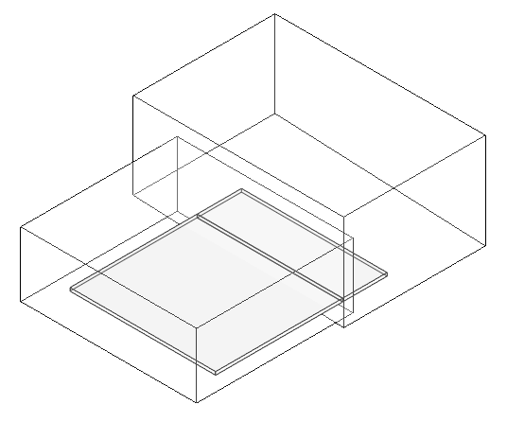

1. **Walls**

>> Find profile curves of a wall, and gather information about the inserted family instances on the wall.

>> Create an extruded sold following the profile curves and collect intersected and difference solid geometry by the selected mass.

>> From the split solid geometry, find an exterior face of the solid and get the orientation vector to draw wall profile curves.

>> Create new walls using the profile curves, and place the family instances at the same location but hosted by new walls created

>> Transfer parameter values from original walls and family instances to newly created walls and placed family instances

**Skipped Parameter: Unconnected Height

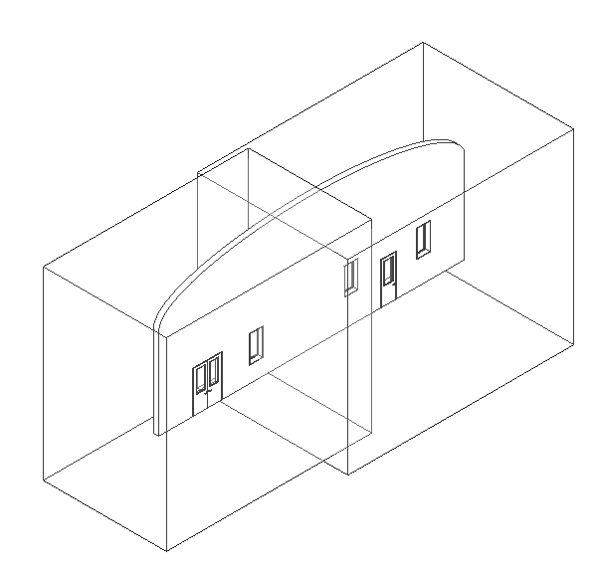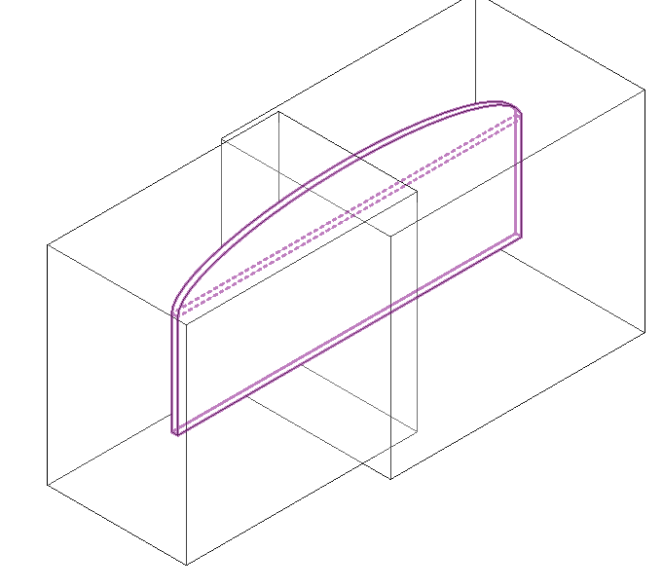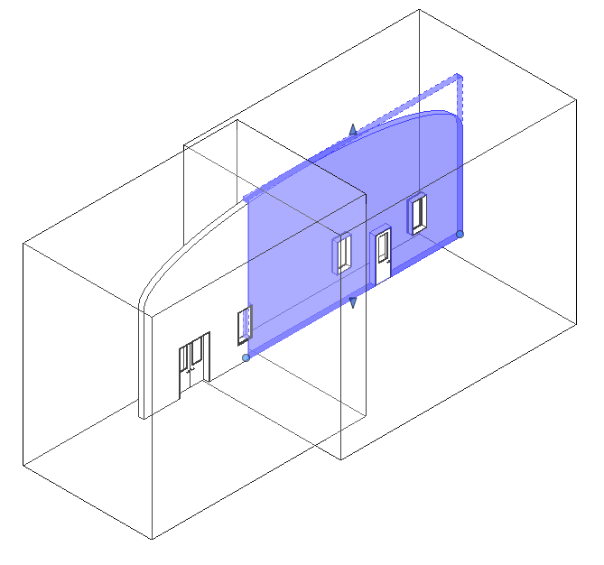

1. **Roofs (Foot Print Roof Only)**

>> Get profiles of the original roof element and create a temporary extruded solid to get intersected and difference solid

>> Using the solid resulted from Boolean operations, draw profile curves on the bottom face of the solid

>> Create new roofs based on the profile curves and edit shapes if it has user drawn crease lines or points.

>> Transfer parameter values from the original element to new roofs.

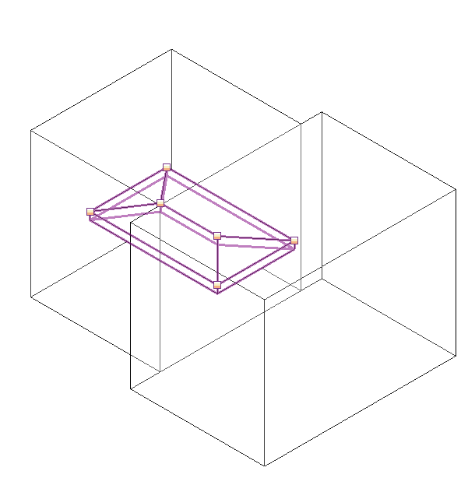 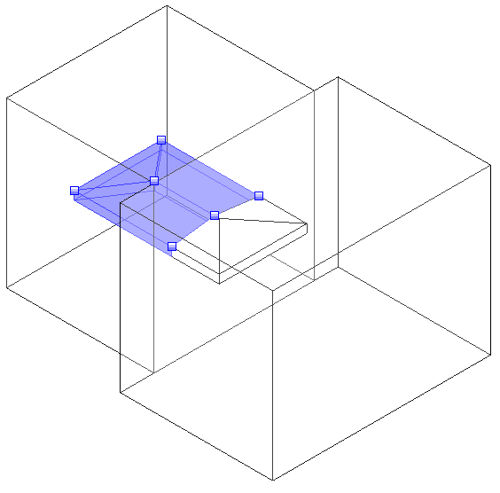

1. **Columns / Structural Columns**

>> If the original column is slanted, it will find the location curve of the instance.

>> Otherwise, if the column is just erected vertically, it will draw a line starting from the location point to the top end of the column.

>> By executing intersection operation between the location curve and faces of the selected mass, draw two divided curves that connect each end points and the intersection point.

>> Place new family instances of columns transferring the information from the original columns

**Skipped parameter: Base Offset, Top Offset

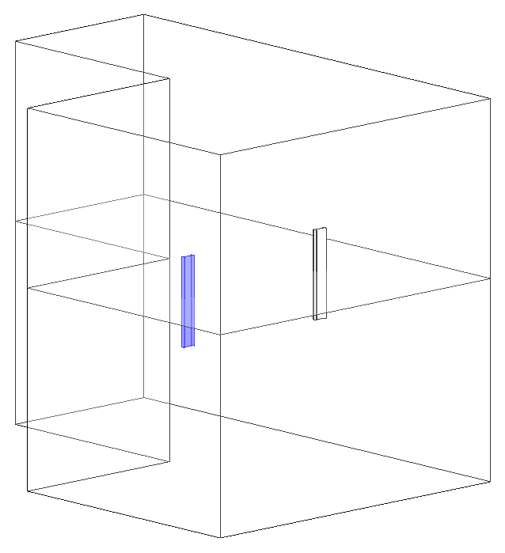 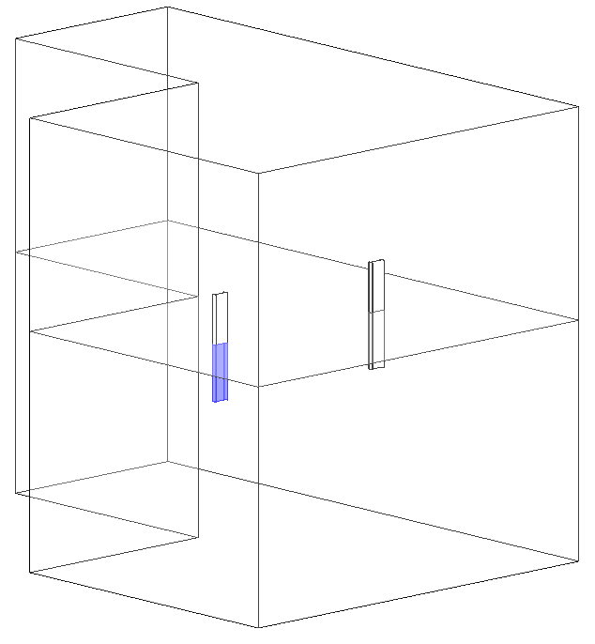

1. **Structural Framings**

>> Find the location curve of a structural Framing.

>> By executing intersection operation between the location curve and faces of the selected mass, draw two divided curves that connect each end points and the intersection point.

>> Place new family instances of columns transferring the information from the original framing.

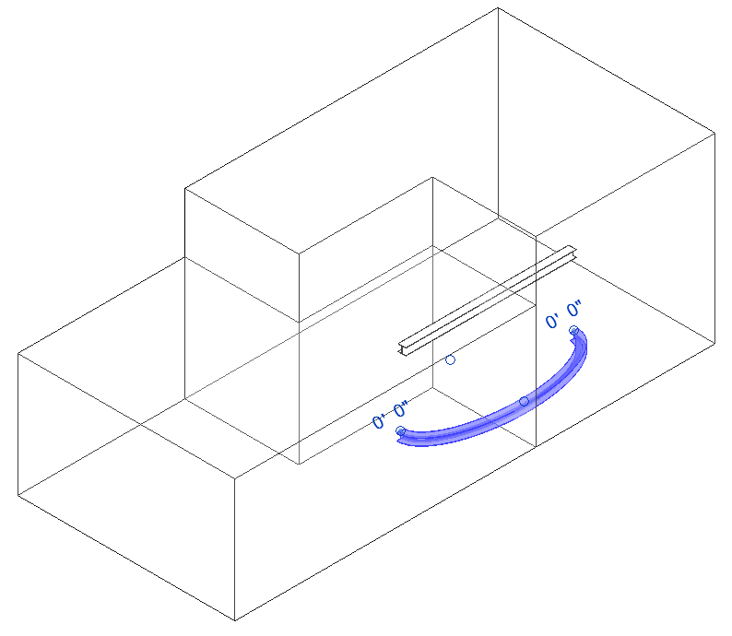 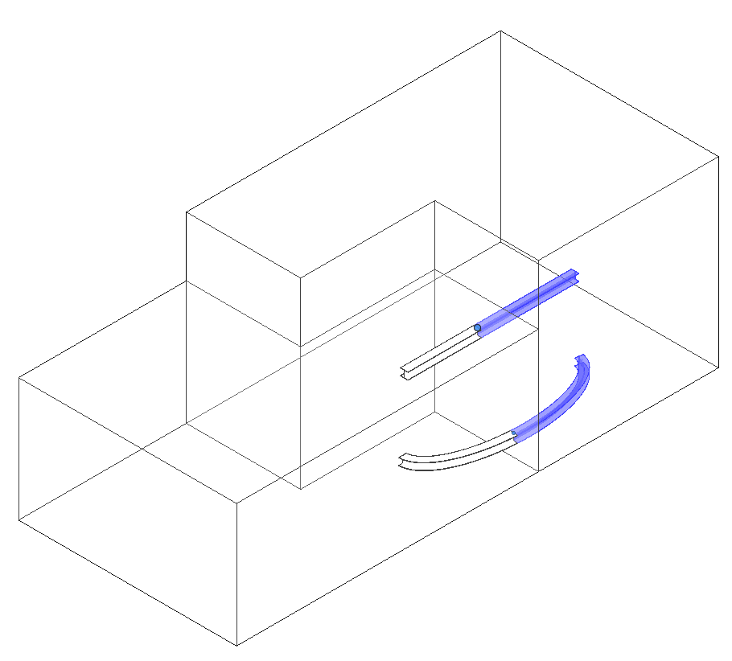

1. **Conduits / Ducts / Pipes**

>> From the location curve of each element, find end points and an intersection point to create conduits, ducts or pipes

>> Create new elements and transfer parameter values from the original elements.

